Name: Atharva Salitri
Year & Branch: TY-CSAI-B
Batch: 2
Roll no: 29
PRN: 12310120
Subject: Cloud Computing
ASSIGNMENT NO: 05
Problem Statement: Deploy a stateless/stateful application on Kubernetes cluster.

Theory:
Kubernetes, also known as K8s, is an open-source system for automating deployment, scaling, and management of containerized applications. It groups containers that make up an application into logical units for easy management and discovery. Kubernetes can help you deliver and manage containerized, legacy, and cloud-native apps, as well as those being refactored into microservices.
Kubernetes, the container-centric management software, has become thede facto standard to deploy and operate containerized applications. Google Cloud is the birthplace of Kubernetes—originally developed at Google and released as open source in 2014. Kubernetes builds on 15 years of running Google's containerized workloads and the valuable contributions from the open source community. Inspired by Google’s internal cluster management system, Borg, Kubernetes makes everything associated with deploying and managing your application easier. Providing automated container orchestration, Kubernetes improves your reliability and reduces the time and resources attributed to daily operations.

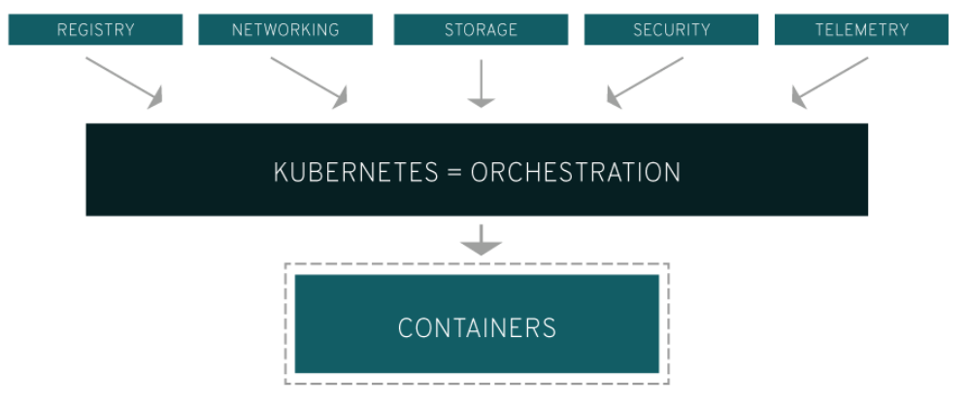

Kubernetes gives you the orchestration and management capabilities required to deploy containers, at scale, for these workloads.Kubernetes orchestration allows you to build application services that span multiple containers, schedule those containers across a cluster, scale those containers, and manage the health of those containers over time. With Kubernetes you can take effective steps toward better IT security.

Kubernetes also needs to integrate with networking, storage, security, telemetry, and other services to provide a comprehensive container infrastructure. Linux containers give your microservice-based apps an ideal application deployment unit and self-contained execution environment. And microservices in containers make it easier to orchestrate services, including storage, networking, and security.

This significantly multiplies the number of containers in your environment, and as those containers accumulate, the complexity also grows. Kubernetes fixes a lot of common problems with container proliferation by sorting containers together into "pods." Pods add a layer of abstraction to grouped containers, which helps you schedule workloads and provide necessary services—like networking and storage—to those containers.

Other parts of Kubernetes help you balance loads across these pods and ensure you have the right number of containers running to support your workloads.

What is a Kubernetes cluster?
A working Kubernetes deployment is called a cluster, which is a group of hosts running Linux® containers. You can visualize a Kubernetes cluster as two parts: the control plane and the compute machines, or nodes.

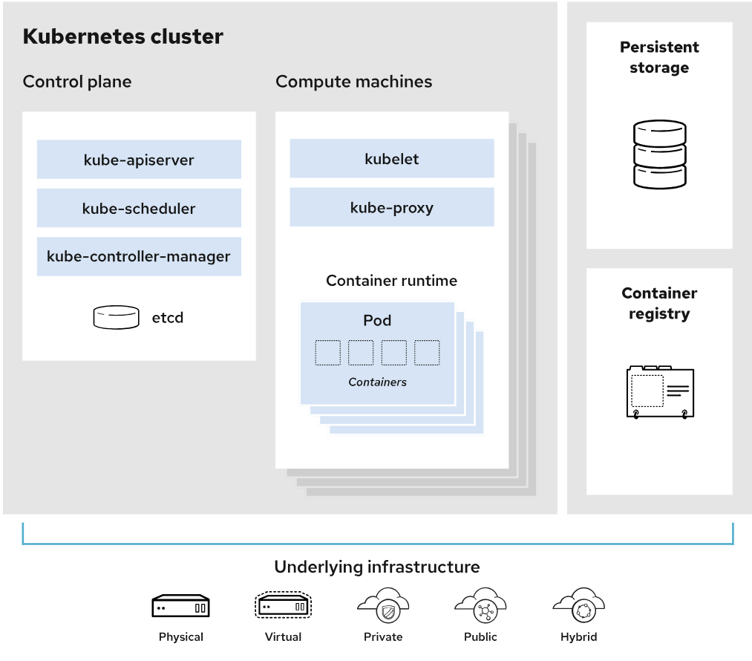

Each node is its own Linux environment, and could be either a physical or virtual machine. Each node runs pods, which are made up of containers.

The control plane is responsible for maintaining the desired state of the cluster, such as which applications are running and which container images they use. Compute machines actually run the applications and workloads. The control plane takes commands from an administrator (or DevOps team) and relays those instructions to the compute machines.

This handoff works with a multitude of services to automatically decide which node is best suited for the task. Services decouple work definitions from the pods and automatically get service requests to the right pod—no matter where it moves in the cluster or even if it’s been replaced. It allocates resources and assigns the pods in that node to fulfill the requested work.
Kubernetes runs on top of an operating system and interacts with pods of containers running on the nodes.
The desired state of a Kubernetes cluster defines which applications or other workloads should be running, along with which images they use, which resources should be made available to them, and other such configuration details.

There is little change to how you manage containers using this type of infrastructure. Your involvement just happens at a higher level, giving you better control without the need to micromanage each separate container or node.

Where you run Kubernetes is up to you. This can be on bare metal servers, virtual machines (VMs), public cloud providers, private clouds, and hybrid cloud environments. One of Kubernetes’ key advantages is it works on many different kinds of infrastructure

Kubernetes Features
- Automated rollouts and rollbacks: Kubernetes progressively rolls out changes to your application or its configuration, while monitoring application health to ensure it doesn't kill all your instances at the same time. If something goes wrong, Kubernetes will rollback the change for you. Take advantage of a growing ecosystem of deployment solutions.

- Service discovery and load balancing: No need to modify your application to use an unfamiliar service discovery mechanism. Kubernetes gives Pods their own IP addresses and a single DNS name for a set of Pods, and can load-balance across them.

- Storage orchestration: Automatically mount the storage system of your choice, whether from local storage, a public cloud provider, or a network storage system such as iSCSI or NFS.

- Self-healing: Restarts containers that fail, replaces and reschedules containers when nodes die, kills containers that don't respond to your user-defined health check, and doesn't advertise them to clients until they are ready to serve.

- Secret and configuration management: Deploy and update Secrets and application configuration without rebuilding your image and without exposing Secrets in your stack configuration.

- Automatic bin packing: Automatically places containers based on their resource requirements and other constraints, while not sacrificing availability. Mix critical and best-effort workloads in order to drive up utilization and save even more resources.

- Batch execution: In addition to services, Kubernetes can manage your batch and CI workloads, replacing containers that fail, if desired.

- Horizontal scaling: Scale your application up and down with a simple command, with a UI, or automatically based on CPU usage.

- IPv4/IPv6 dual-stack: Allocation of IPv4 and IPv6 addresses to Pods and Services

- Designed for extensibility: Add features to your Kubernetes cluster without changing upstream source code.

Kubernetes vs. Docker
Docker can be used as a container runtime that Kubernetes orchestrates. When Kubernetes schedules a pod to a node, the kubelet (the service that makes sure each container is running) on that node will instruct Docker to launch the specified containers.

The kubelet then continuously collects the status of those containers from Docker and aggregates that information in the control plane. Docker pulls containers onto that node and starts and stops those containers.

The difference when using Kubernetes with Docker is that an automated system asks Docker to do those things instead of the admin doing so manually on all nodes for all containers.

Step 1: Install Docker Desktop (with Kubernetes support)
- Install Docker Desktop:
  - Download Docker Desktop for Windows from the official website
  - Run the installer and follow the on-screen instructions.
  - Restart your computer if prompted.
- Enable Kubernetes:
- Open Docker Desktop.
- Go to Settings > Kubernetes.
- Check the box Enable Kubernetes and click Apply & Restart.
- Docker will now set up a local Kubernetes cluster. This might take a few minutes.
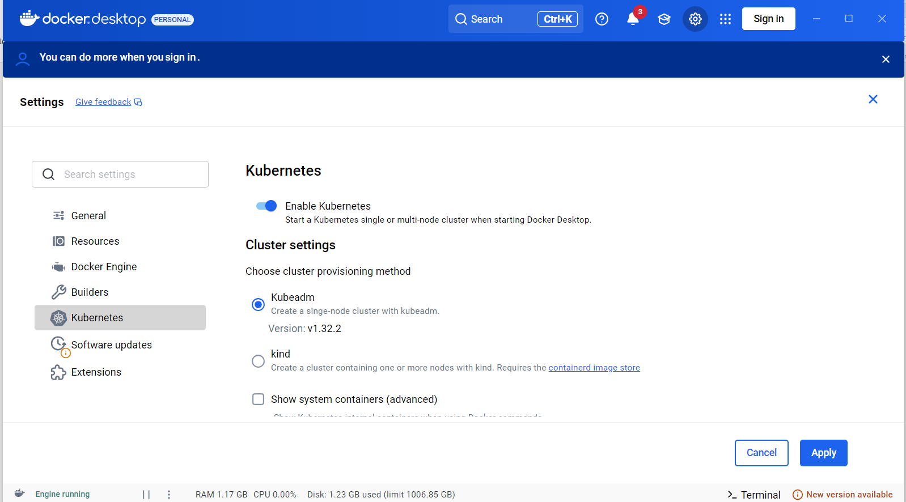
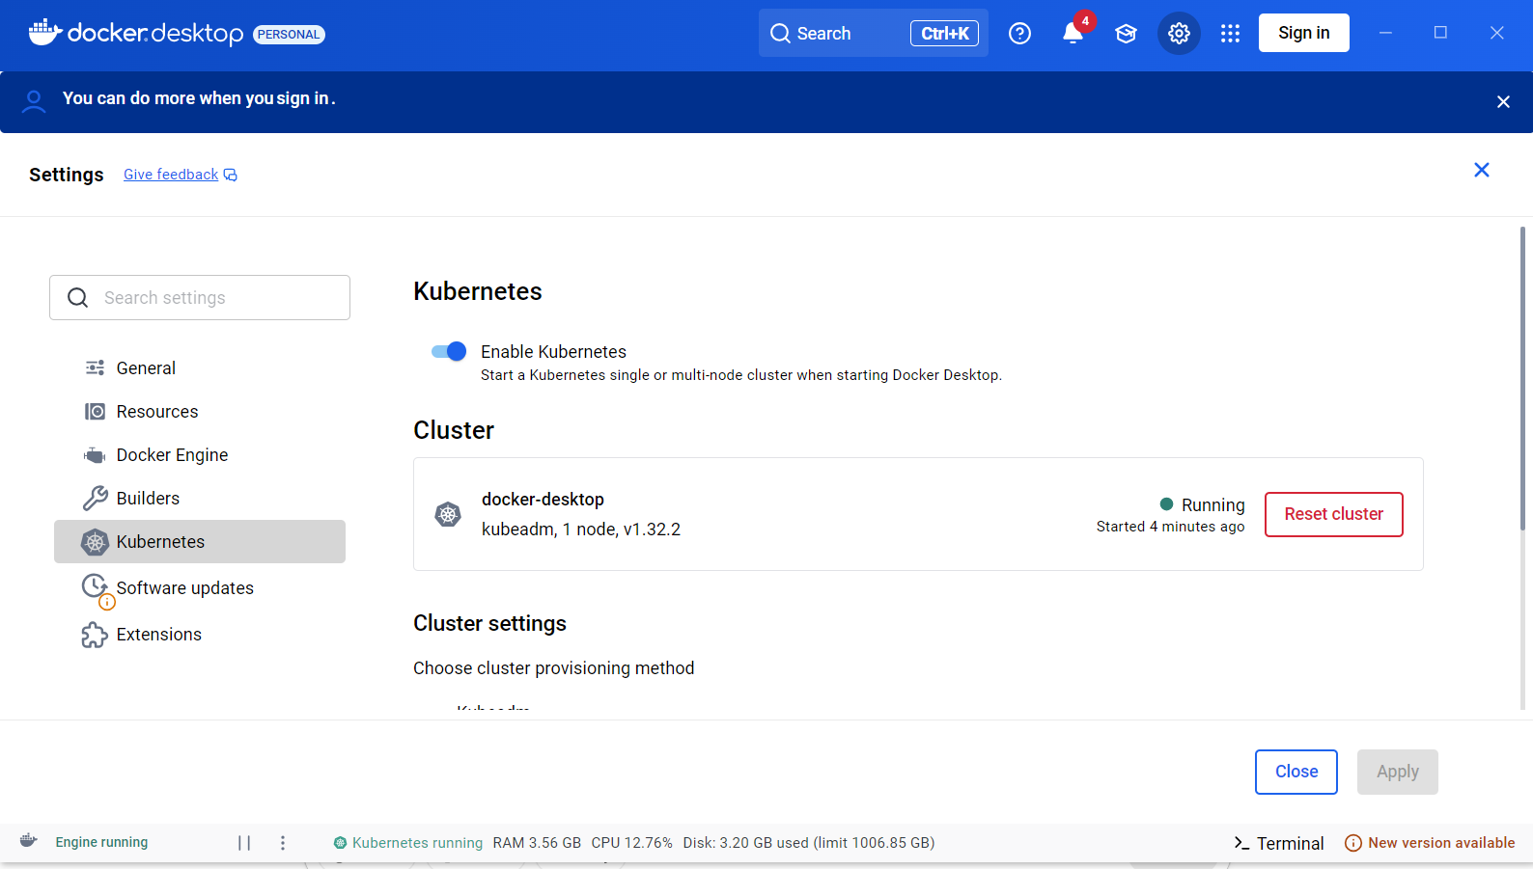

Step 2: Install kubectl
kubectl is the command-line tool for interacting with Kubernetes.
- Install kubectl using Chocolatey (optional):
  - Open PowerShell or Command Prompt as an administrator.
  - Run the following command to install kubectl using Chocolatey:
  - choco install kubernetes-cli
- Verify kubectl installation:
  - Open a terminal and check if kubectl is installed:
  - kubectl version --client
If everything works, it will show you the version of the kubectl client.
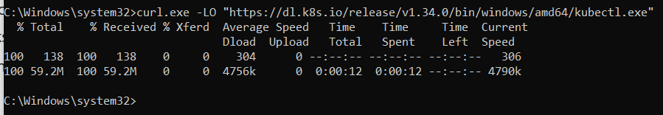
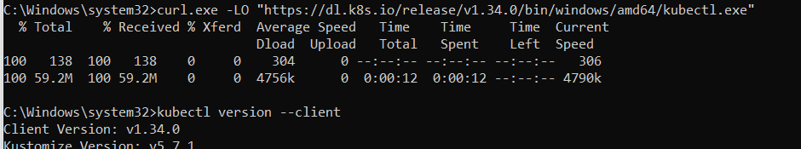

Step 3: Verify the Kubernetes Cluster
To check if your Kubernetes cluster is running and available:
- Run:
- kubectl get nodes
You should see your node listed as Ready.
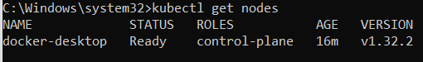

Step 4: Set Up a Stateless Application (Example: Nginx)
For a stateless application, we will deploy a basic Nginx web server.
- Create a Deployment YAML file (nginx-deployment.yaml):
Create a YAML file for the Nginx deployment. Open any text editor (like Notepad++) and create a new file named nginx-deployment.yaml with the following content:
apiVersion: apps/v1
kind: Deployment
metadata:
name: nginx-deployment
spec:
replicas: 3
selector:
matchLabels:
app: nginx
template:
metadata:
labels:
app: nginx
spec:
containers:
- name: nginx
image: nginx:latest
ports:
- containerPort: 80
This will create a deployment with 3 replicas of Nginx.
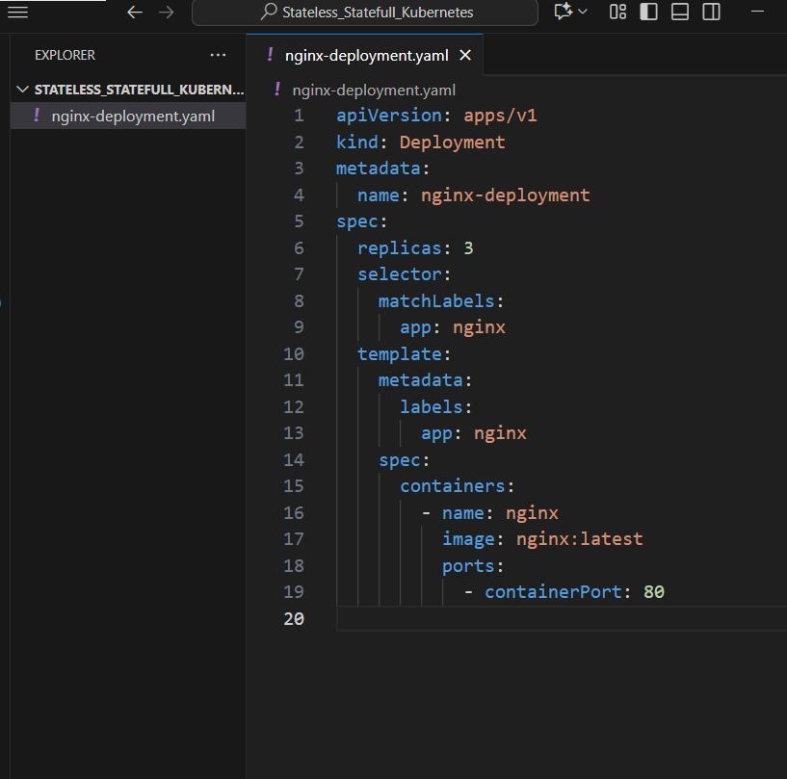
apiVersion: v1
kind: Service
metadata:
name: nginx-service
spec:
selector:
app: nginx
ports:
- protocol: TCP
port: 80
targetPort: 80
nodePort: 30000 # Exposes the service on port 30000 on your machine
type: NodePort
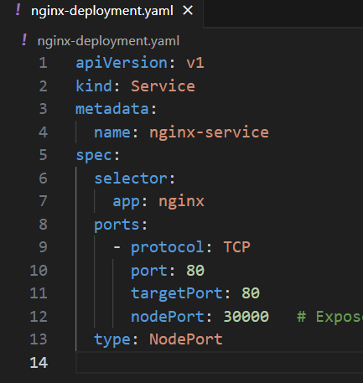
- Apply the deployment to the Kubernetes cluster:
Run the following command to deploy it:
kubectl apply -f nginx-deployment.yaml

- Verify the Deployment:
Check if the pods are running:
kubectl get pods
You should see 3 pods running with the nginx container.
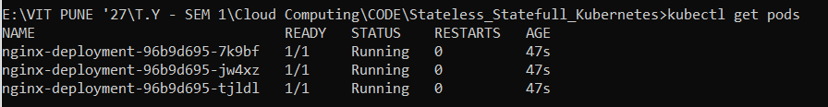
- Expose the Deployment (create a service):
Create a service to expose Nginx to the outside world (via port 80):
kubectl expose deployment nginx-deployment --type=LoadBalancer --name=nginx-service

- Get the service's external IP:
It may take a few seconds to a minute for the LoadBalancer service to be assigned an external IP address. You can check it by running:
kubectl get services

Once you see the external IP, access your Nginx application by navigating to that IP in your web browser.
kubectl apply -f nginx-service.yaml
http://localhost:30000
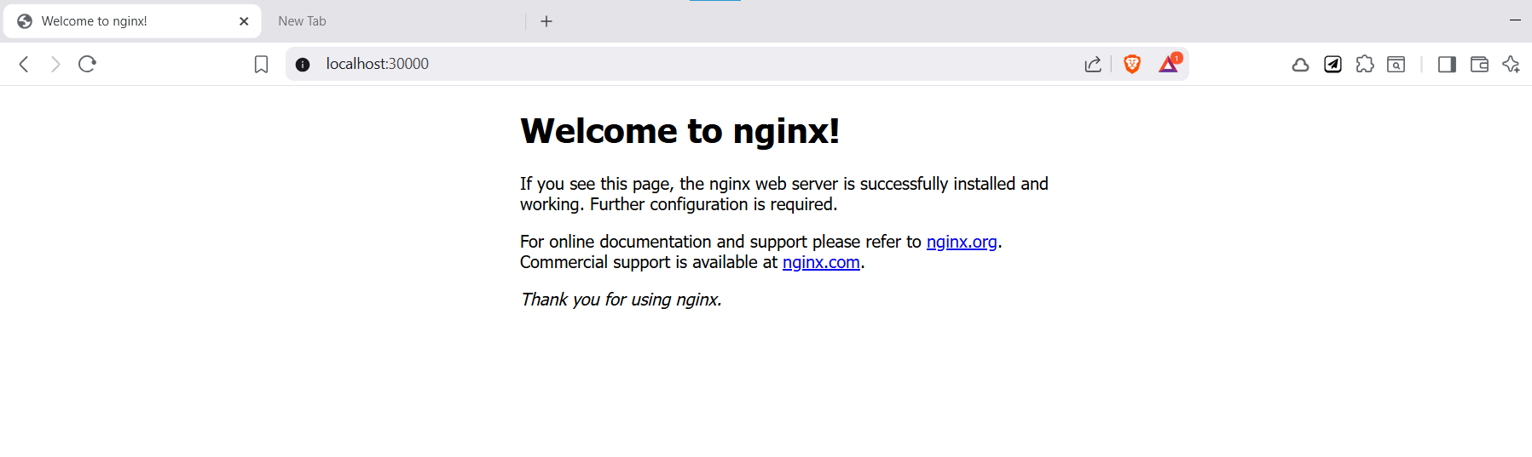
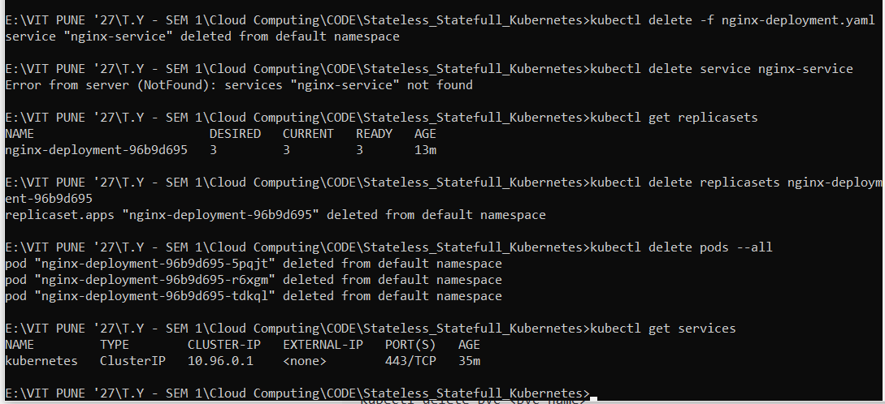
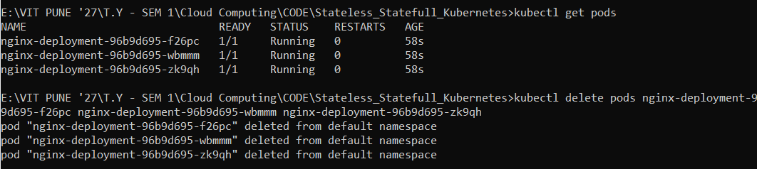
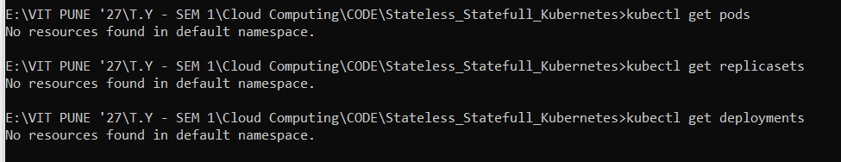

Step 5: Set Up a Stateful Application (Example: MySQL)
Stateful applications typically require persistent storage and unique network identities. Let's deploy a MySQL database as an example.
- Create a Persistent Volume (PV) and Persistent Volume Claim (PVC):
Create a mysql-pv-pvc.yaml file to define the persistent storage and claim for MySQL:
apiVersion: v1
kind: PersistentVolume
metadata:
name: mysql-pv
spec:
capacity:
storage: 1Gi
accessModes:
- ReadWriteOnce
hostPath:
path: /tmp/mysql-data
---
apiVersion: v1
kind: PersistentVolumeClaim
metadata:
name: mysql-pvc
spec:
accessModes:
- ReadWriteOnce
resources:
requests:
storage: 1Gi
The hostPath type is used for local storage on the node, but for production, you should use a more suitable storage provider like NFS, cloud volumes, or a block storage system.
- Create a StatefulSet YAML file for MySQL (mysql-statefulset.yaml):
Create a mysql-statefulset.yaml file with the following content:
apiVersion: apps/v1
kind: StatefulSet
metadata:
name: mysql
spec:
serviceName: "mysql"
replicas: 1
selector:
matchLabels:
app: mysql
template:
metadata:
labels:
app: mysql
spec:
containers:
- name: mysql
image: mysql:5.7
env:
- name: MYSQL_ROOT_PASSWORD
value: "rootpassword"
volumeMounts:
- name: mysql-storage
mountPath: /var/lib/mysql
ports:
- containerPort: 3306
volumeClaimTemplates:
- metadata:
name: mysql-storage
spec:
accessModes: [ "ReadWriteOnce" ]
resources:
requests:
storage: 1Gi
The StatefulSet ensures that the MySQL pod retains its identity, and the volume persists data across pod restarts.
- Deploy the StatefulSet and PVC:
Apply the YAML files to Kubernetes:
kubectl apply -f mysql-pv-pvc.yaml
kubectl apply -f mysql-statefulset.yaml
- Verify the StatefulSet:
Check if the pods are running correctly:
kubectl get pods
- Expose MySQL:
You can expose MySQL via a ClusterIP service:
kubectl expose pod mysql-0 --port=3306 --name=mysql-service
Now, you can connect to MySQL using mysql-service within the cluster.

Step 6: Clean Up
After finishing your work, you can delete the deployments and services to clean up your cluster:
- Delete the stateless application (Nginx):
- kubectl delete -f nginx-deployment.yaml
- Delete the stateful application (MySQL):
- kubectl delete -f mysql-statefulset.yaml
- kubectl delete -f mysql-pv-pvc.yaml

Optional: Using Minikube (for a more isolated setup)
If you want a local Kubernetes cluster that is isolated from Docker Desktop, you can use Minikube:
- Install Minikube using this guide.
- Start a Minikube cluster:
- minikube start
- Set the kubectl context to Minikube:
- kubectl config use-context minikube
- Continue with the deployment steps above, just replace kubectl with your Minikube setup.

Conclusion
You’ve now set up a Kubernetes cluster on Windows 10 using Docker Desktop, deployed a stateless Nginx application, and a stateful MySQL database. You can experiment with more complex applications, and scale your deployments as needed. Happy Kubernetes-ing!

To update your application from a Stateless (Deployment-based) to a Stateful application in Kubernetes, we need to switch the setup from using a Deployment to using a StatefulSet. This is typically done to maintain stable identities for each pod, which is a core feature of stateful applications (i.e., each pod gets a persistent name and stable storage).

Steps to Create a StatefulSet for NGINX (with NodePort on Port 30000)
I'll walk you through updating the code for a StatefulSet while keeping the NodePort service configuration for local access on port 30000.

1. Update StatefulSet for NGINX
You need to create a StatefulSet instead of a Deployment. Here's an updated YAML configuration for the StatefulSet:
nginx-statefulset.yaml:
apiVersion: apps/v1
kind: StatefulSet
metadata:
name: nginx-statefulset
spec:
serviceName: "nginx-service"
replicas: 3
selector:
matchLabels:
app: nginx
template:
metadata:
labels:
app: nginx
spec:
containers:
- name: nginx
image: nginx:latest
ports:
- containerPort: 80
volumeMounts:
- name: nginx-data
mountPath: /usr/share/nginx/html
volumeClaimTemplates:
- metadata:
name: nginx-data
spec:
accessModes: [ReadWriteOnce]
resources:
requests:
storage: 1Gi
---
apiVersion: v1
kind: Service
metadata:
name: nginx-service
spec:
selector:
app: nginx
ports:
- protocol: TCP
port: 80
targetPort: 80
nodePort: 30000 # NodePort to expose on localhost:30000
type: NodePort

Explanation:
- StatefulSet:
  - This replaces the Deployment. The StatefulSet ensures each pod has a unique identity and stable storage.
  - The serviceName ensures that each pod has a stable network identity.
  - replicas: 3 means 3 replicas (like in the original Deployment).
  - The volumeClaimTemplates section ensures that each pod gets its own PersistentVolumeClaim for storage. This is important for stateful applications.
- Service:
  - We’re using a NodePort to expose the service on port 30000 (as you requested), allowing you to access the NGINX application on localhost:30000.

2. Apply the StatefulSet Configuration
Run the following command to apply the new StatefulSet configuration:
kubectl apply -f nginx-statefulset.yaml

3. Verify the Resources
After applying the configuration, verify that the StatefulSet and Service have been created:
- Check StatefulSet:
- kubectl get statefulsets
- Check Pods:
- kubectl get pods
The pods should be named like nginx-statefulset-0, nginx-statefulset-1, and nginx-statefulset-2 (since it's a StatefulSet, each pod will have a unique ordinal number).
- Check Services:
- kubectl get services
The service nginx-service should be listed with NodePort 30000.

4. Access the Application
After the StatefulSet and service are running, you should be able to access the NGINX application at:
http://localhost:30000
If everything is set up correctly, you should see the default NGINX page.

5. Verify StatefulSet Pods and Storage
To confirm that the StatefulSet is creating persistent volumes:
- Check Pods:
- kubectl get pods
- Check Persistent Volume Claims (PVCs):
- kubectl get pvc
Each pod in the StatefulSet should have its own Persistent Volume Claim.

